**Semester 1 (Unit 3) Examination, 2017**

**Question/Answer Booklet**

**MATHEMATICS METHODS**

**Section Two: Calculator-assumed**

Student Name/Number: ______________________________________________

Teacher Name: ______________________________________________

**Time allowed for this section**

Reading time before commencing work: ten minutes

Working time for this section: hundred minutes

**Materials required/recommended for this section**

**To be provided by the supervisor:** This Question/Answer Booklet

Formula Sheet (retained from Section One)

**To be provided by the candidate:**

Standard items: pens (blue/black preferred), pencils (including coloured), sharpener, correction fluid/tape, eraser, ruler, highlighters

Special items: drawing instruments, templates, notes on ____ unfolded sheets of A4 paper, and up to three calculators approved for use in the WACE examinations

**Important note to candidates**

No other items may be taken into the examination room. It is **your** responsibility to ensure that you do not have any unauthorised notes or other items of a non-personal nature in the examination room. If you have any unauthorised material with you, hand it to the supervisor **before** reading any further.

**Structure of this paper**

|  |  |  |  |  |  |
| --- | --- | --- | --- | --- | --- |
| Section | Number of questions available | Number of questions to be answered | Working time (minutes) | Marks available | Percentage of exam |
| Section One: Calculator-free | 7 | 7 | 50 | 50 | 35 |
| Section Two: Calculator-assumed | 11 | 11 | 100 | 100 | 65 |
|  | | | | | 100 |

**Instructions to candidates**

1. The rules for the conduct of School exams are detailed in the *_______________________________________School/College assessment policy*. Sitting this examination implies that you agree to abide by these rules.
2. Write your answers in this Question/Answer Booklet.

3. You must be careful to confine your responses to the specific questions asked and to follow any instructions that are specific to a particular question.

1. Spare pages are included at the end of this booklet. They can be used for planning your responses and/or as additional space if required to continue an answer.
   * Planning: If you use the spare pages for planning, indicate this clearly at the top of the page.
   * Continuing an answer: If you need to use the space to continue an answer, indicate in the original answer space where the answer is continued, i.e. give the page number. Fill in the number of the question that you are continuing to answer at the top of the page.
2. **Show all working clearly.** Your working should be in sufficient detail to allow your answers to be checked readily and for marks to be awarded for reasoning. Incorrect answers given without supporting reasoning cannot be allocated any marks. For any question or part question worth more than two marks, valid working or justification is required to receive full marks. If you repeat any question, ensure that you cancel the answer you do not wish to have marked.
3. It is recommended that you **do not use pencil**, except in diagrams.
4. The Formula Sheet is **not** to be handed in with your Question/Answer Booklet.

**Section Two: Calculator-assumed (100 Marks) Weighting 65%**

This section has **(eleven)** **11** questions. Answer **all** questions. Write your answers in the spaces provided. Spare pages are included at the end of this booklet.

Suggested working time: **100 minutes**.

**Question 8 (6 marks)**

The base radius of a conical pile of sand is twice its height. If the volume of the sand is initially 60 $m^{3}$ and then another 1 $m^{3}$ of sand is added, use the increments formula to estimate the increase in the height of pile.

Quote your result in millimetres and you should assume that that radius of the cone remains twice its height.

**Question 9 (13 marks)**

The function $f\left(x\right)$ is defined, for $0≤x≤π,$ by the rule



(a) Determine $f'(x)$ and $f^{''}\left(x\right),$ the first and second derivatives of $f(x)$. (2 marks)

(b) Determine the maximum value of $f(x)$, in exact form, and correct to 3 significant figures.

Justify your answer. (5 marks)

(c) Determine the exact coordinates of the point of inflection on the graph of $y=f\left(x\right).$

(2 marks)

(d) Sketch the graph of $y=f\left(x\right)$ on the coordinate axis system below. Indicate on your graph the location of the point of inflection. (4 marks)

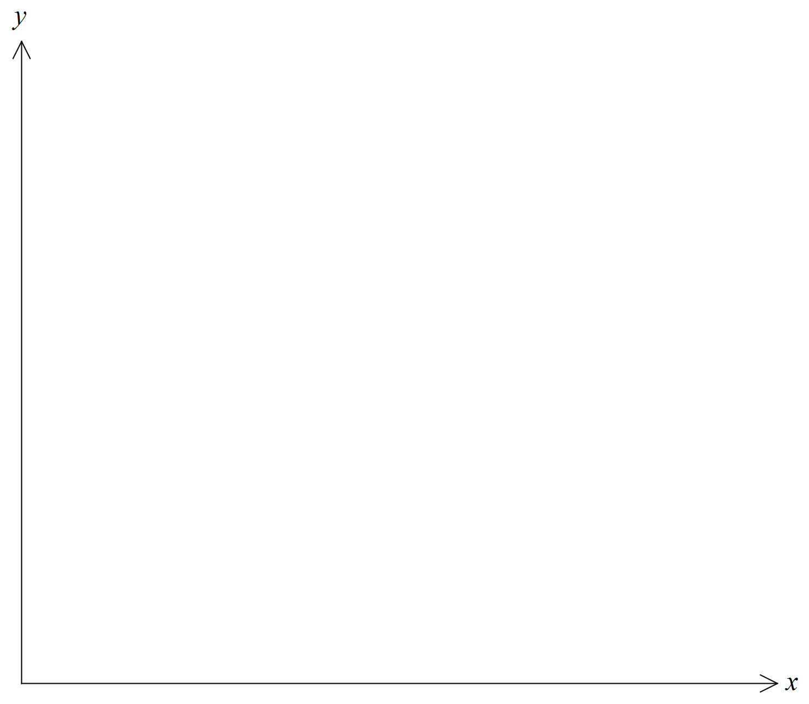

**Question 10 (10 marks)**

Two isotopes of a radioactive chemical element decay at different rates. The half-life of isotope $α$ is 5.8 years and the half-life of isotope $β$ is 7.6 years.

(a) Which isotope decays faster? Justify your answer. (1 mark)

The amountkg of isotope $α$ at a particular location $t$ years from now is given by

.

(b) Evaluate the constants $A_{0}$ and $k$, given that there is now 8.5 kg of isotope $α$ at the location. (3 marks)

(c) How long will it take for the amount of isotope $α$ to reduce to 1 g? (2 marks)

(d) There is currently 2 kg of isotope $β$ in the same location. When will the amounts of isotopes $α$ and $β$ present at the location have equal weight? (4 marks)

**Question 11 (7 marks)**

In any given week, the probability that a car sales person makes a specified number of sales is given below. Let the number of car sales on any given week be represented by the random variable,.

|  |  |  |  |  |  |
| --- | --- | --- | --- | --- | --- |
| Number of cars sold () | 2 | 3 | 4 | 5 | 6 |
|  | 0.4 | 0.3 | 0.15 | 0.09 | 0.06 |

(a) Determine the expected number of car sales on any given week. (2 marks)

(b) Determine the variance of , Var(). (2 marks)

(c) Determine the probability that, on any given week, the number of sales will be within one standard deviation of the expected weekly sales. (3 marks)

**Question 12 (7 marks)**

One thousand people were asked the following question:

Do you regularly use social media?

The responses were classified by age of the respondents, as shown in the table below.

|  |  |  |  |
| --- | --- | --- | --- |
| Response | Age <30 (years) | Age  30 (years) | Total |
| Yes | 400 | 250 | 650 |
| No | 50 | 300 | 350 |
| Total | 450 | 550 | 1000 |

(a) A random variableis defined to be the probability that a respondent regularly uses social media. Define the probability distribution, in tabular form, for the random variable (2 marks)

(b) State the type of probability distribution that underlies the random variable. (1 mark)

(c) If one of the respondents is selected at random, determine:

(i) The probability that the respondent was over 30 years of age and regularly used social media. (1 mark)

(ii)  The probability that the respondent was over 30 years of age given that he/she regularly used social media. (1 mark)

(d) Two respondents over 30 years of age were selected at random. What is the probability they both regularly use social media? (2 marks)

**Question 13 (7 marks)**

Susan passes through three sets of traffic lights on the way to work. They are not synchronized and the probability of any traffic light being red is 0.15.

is a discrete random variable representing the number of red lights met in the three sets of traffic lights. can take the values 0, 1, 2 or 3

1. Determine , the probability that Susan does not have to stop for a red light on her way to work. (2 marks)
2. Complete the table for the probability function of . (3 marks)

|  |  |  |  |  |
| --- | --- | --- | --- | --- |
| *x* | 0 | 1 | 2 | 3 |
|  | (0.8)3 =0.512 | 3(0.2)(0.8)2 = 0.384 | 3(0.2)2 (0.8)= 0.096 | (0.2)3=0.008 |

1. Determine the mean and the standard deviation of the number of red lights Susan encounters on her way to work. (2 marks)

**Question 14 (7 marks)**

(a) Given the function 

(i) Determine 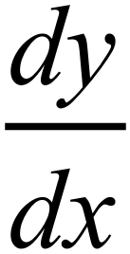. (1 marks)

(ii) Using part (a), determine the exact value of . (2 marks)

(b) Given  , determine . (4 marks)

**Question 15 (9 marks)**

(a) The area of the region bounded by the curve  ,where *k* is a positive constant, the *x*-axis, and the line *x* = 9 is 27. Determine the value of *k*. (3 marks)

(b) For the domain , the curves  and  intersect at

, and  where .

(i) Determine the values of a, b and c. (3 marks)

(ii) Write down an integral to calculate the total area bounded by the two curves for the domain . (2 marks)

(iii) Evaluate the integral established in part (ii). (1 mark)

intersect when

**Question 16 (11 marks)**

A distribution manager knows that 5% of the computers in the store are defective. Fifteen computers are selected randomly for testing.

(a) Determine the probability that two of the computers selected are defective. (3 marks)

(b) Determine the probability that fewer than two defective computers are selected.

(3 marks)

(c) Determine the probability that four or more of the computers selected are defective.

(2 marks)

(d) What is the greatest number of computers that can be selected from the store so that the probability that there is at least one defective computer selected is less than 0.55?

Explain how you determined your answer. (3 marks)

**Question 17 (14 marks)**

Two marbles are drawn from a bag containing 4 red and 9 black marbles.

Let the random variable, represent the number of red marbles selected when two are drawn from the bag.

Determine the probability that:

1. Both selected marbles are red (i.e. ). (2 marks)
2. . (2 marks)

Three marbles are drawn from the bag containing 4 red and 9 black marbles.

Let the random variable, represent the number of red marbles selected when three are drawn from the bag.

1. Set up a table for the probability function and determine the mean and standard deviation of  (5 marks)

The sampling is repeated, but this time, each marble selected, is identified and replaced. This is repeated three times. The random variable, represents the number of red marbles resulting from the three selections (with replacement).

1. (i) Determine the mean and standard deviation for . (3 marks)

(ii) Identify any similarities or differences between the mean and standard deviation of and of. (2 marks)

**Question 18 (9 marks)**

Let . The graphs of  and  are shown below.





(a) Write an integral statement and use your calculator to evaluate the area of the shaded region that is enclosed by the graph of , the *y*-axis and the line  (3 marks)

Let , where  .

(b) Determine  (1 mark)

Let .

(c) Use the product rule to show that  (3 marks)

(d) Using part (c), determine an expression for in terms of k. (2 marks)

**End of questions**

Additional working space

Question number: __________________

**Acknowledgements**

© MAWA, 2017

This examination is Copyright but may be freely used within the school that purchases this licence.

* The items that are contained in this examination are to be used solely in the school for which they are purchased.
* They are not to be shared in any manner with a school which has not purchased their own licence.
* The items and the solutions/marking keys are to be kept confidentially and not copied or made available to anyone who is not a teacher at the school. Teachers may give feedback to students in the form of showing them how the work is marked but students are not to retain a copy of the paper or the marking guide until the agreed release date stipulated in the purchasing agreement/licence.

*Published by The Mathematical Association of WA*

*12 Cobbler Place, MIRRABOOKA 6061*